43.72: In terms of the number of cesium atoms that decay in one week and the mass
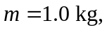 the equivalent dose is
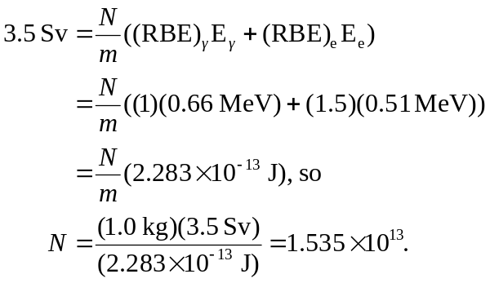
The number 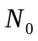 of atoms present is related to 